A
Project Report
On

Graphical Representation
of Stack And Queue
Submitted to
“SHIVAJI UNIVERSITY, KOLHAPUR”
For the partial fulfillment of the requirement for the award
MASTER OF COMPUTER APPLICATIONS
(SEM-II)

By
Nikita Dilip Kadapure
Gita Mahendran Mudliyar
Under the guidance of
Dr.S.T.Bhosale

Through
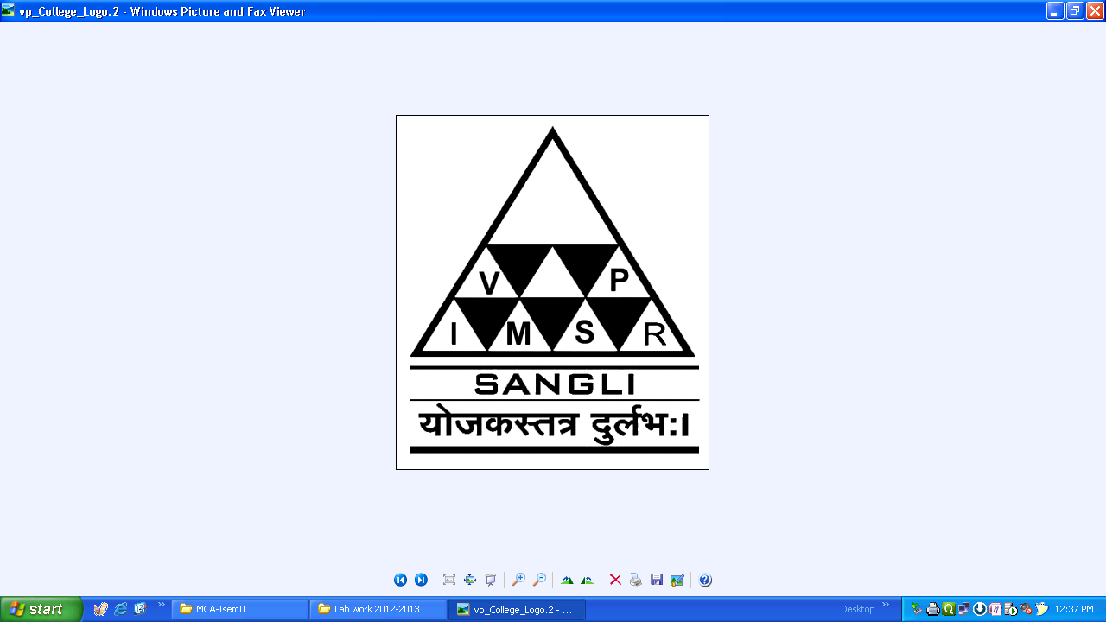

The Principal
V. P. INSTITUTE OF MANAGEMENT STUDIES AND RESEARCH, SANGLI.

2018-19

V. P. Institute of Management Studies & Research
Sangli. - 416414

Certificate

Department of Computer Applications

This is to certify that, the project report entitled ”Graphical Representation of Stack and Queue” is record of project work carried out in this college by Nikita Dilip Kadapure and Gita Mahendran Mudliyar in partial fulfillment of the award of Master of Computer Application(Sem-II) as laid down by SHIVAJI UNIVERSITY, KOLHAPUR.
This project presents their sincere work carried out under my guidance in the year 2018-19.

Date:

Dr. S.T.Bhosale Dr. S.T.Bhosale
Project Guide H.O.D.

Examiner: 1. 2.

DECLARATION

To,
The Registrar,
Shivaji University, Kolhapur

Sir,

We undersigned Nikita Dilip Kadapure and Gita Mahendran Mudliyar hereby declare that, the project report Graphical Representation of Stack and Queue for submitted by us under the guidance of Dr. S. T. Bhosale, is our original work.
We have not reproduced any information from any report submitted to Shivaji University, Kolhapur this year or any of the previous years.
We understand that any such copying is liable to punish in a way that University authorities deem fit.

Place: Sangli
Date:
Nikita Dilip Kadapure ________
Gita Mahendran Mudliyar ________

Acknowledgement

We sincerely express our deep felt gratitude to a number of persons who have helped us throughout our project work.
We wish to express independents and thankfulness to our honorable Principal Dr. R. A. Shinde and the other staff members of our college for their encouragement.
Also we would like to take an opportunity to thank Head of Department Dr. S. T. Bhosale to give us such opportunity.
We would also like to convey feeling of gratitude to our guide Dr. S. T. Bhosale who has guided us throughout our project work knowledge and has encouraged our throughout.
Also we would like to take opportunity to thank Computer faculty members of college Shri. A. A. Govande, Shri A. S Sattikar , Mrs. V. P. Desai, Shri. V. B. Sutar, Shri. S. K. Jagtap, and Mr. M. M. Keripale Sir for extending full support
Lastly, we would also thank our friends who have helped us directly and indirectly.

Place: Sangli
Date:

INDEX
Sr.  No. | Title | Page  No.
1. | Introduction  - About System  - About System Platform  - Operating Environment -Hardware and Software | 1  1  10
2. | System Analysis  2.1 Site Map | 11
3. | Input and Output Design | 12
4. | Coding | 35
5. | User Manual | 48
6. | Limitations and Future Enhancement | 49
7. | Conclusion | 50
8. | Bibliography | 51

